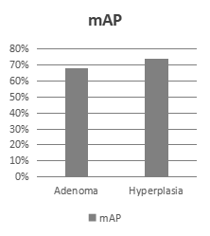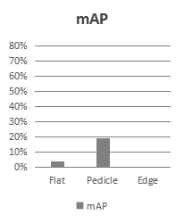

期待的分类

Flat Pedicle Edge

267 97 72

206 200 206

353 224 199

350 336 419

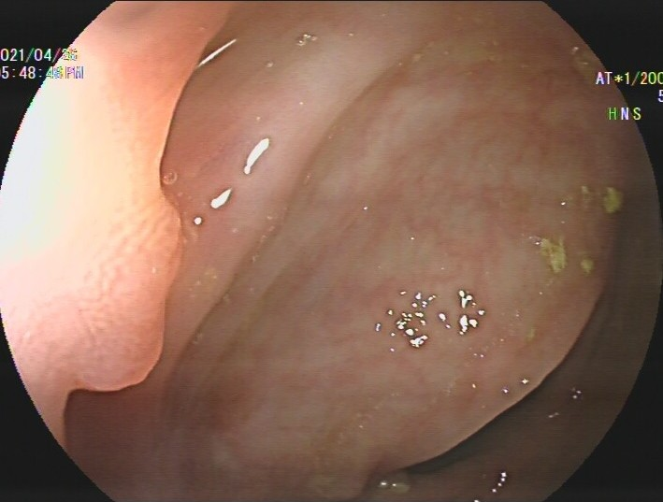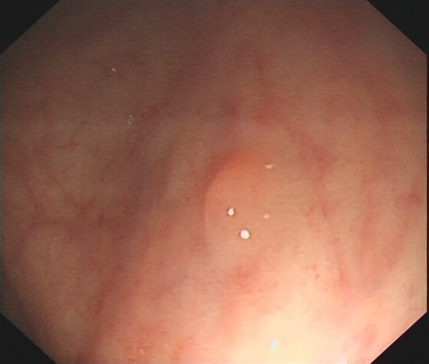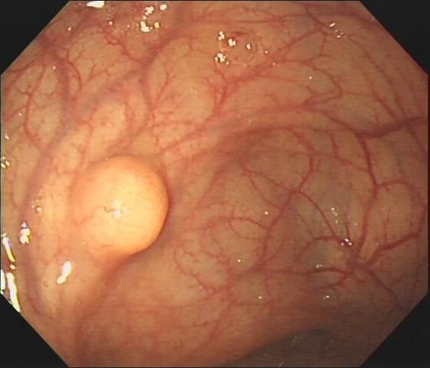

类别

Xmin

Ymin

Xmax

Ymax



**Box**

注释

更多**时间**

图像

需要**医生**



需要**坐标**

1. **Shortcomings of existing methods :**

|  |  |  |  |  |
| --- | --- | --- | --- | --- |
| 图像 | | 图片2 | **图片3** | **图片1** |
| 预测信息 | 类别 | - | - | √ |
| 置信度 | - | √ | - |
| 定位 | √ | √ | √ |





（A）硬标注 （B）不完善的预测 （C）不合适的评价方式

**Advance 3**

**Advance 2**

**Advance 1**

1. **Task of our work :**

|  |  |  |  |  |
| --- | --- | --- | --- | --- |
| Images | |  |  | **Evaluate** |
| Prediction information | category | **√** | **√** | √ |
| confidence | **√** | √ | **√** |
| location | √ | √ | √ |



**Flat:77%**

**Pedicle:89%**

**Edge:91%**

Less **money**



Image

Class



Flat Pedicle Edge

Annotated

Just **class**

Easy Annotation Perfect prediction Appropriate category evaluation

**Challenge 1**

**Challenge 2**

**Challenge 3**

1. **Challenges of our task :**

|  |  |  |  |
| --- | --- | --- | --- |
| 图像 | 86648329A6024F4798C8046C1422E935_13174481 | 4E02AF94176C42728B1E1526F9BE6C65_GXNJ3194581 | 4E02AF94176C42728B1E1526F9BE6C65_GXNJ3194580  **?** |
| Flat |  | **?** | √ |
| Pedicle | **?** | √ |  |
| Edge | √ |  |  |

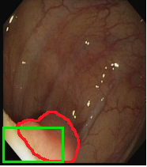

标签

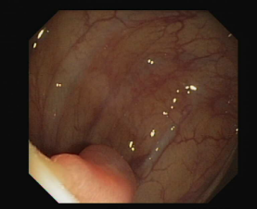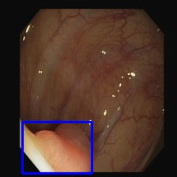

图像



息肉缺失

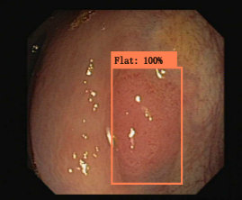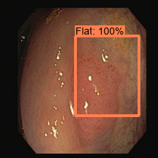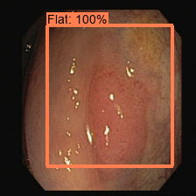

√

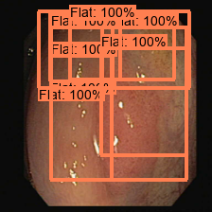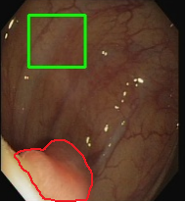

定位错误

**×**

Selective search

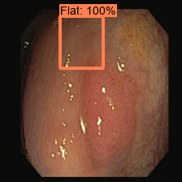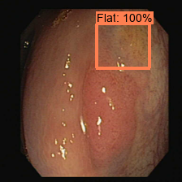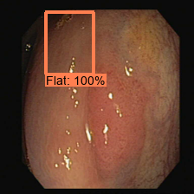

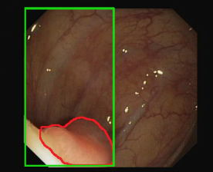

背景噪声

（A）不准确的建议 （B）不具区分性的形态 （C）假阳误报

**Contribution 3**

**Contribution 2**

**Contribution 1**

1. **Our contributions :**

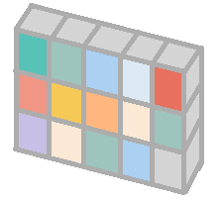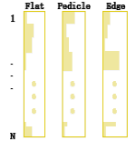

Selective search

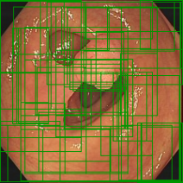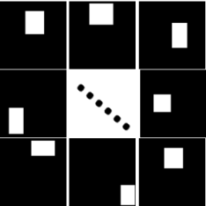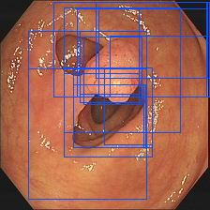

PraNet backbone





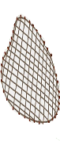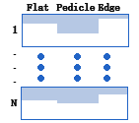

Category filter Region filter

Cross-reference module Space category module Dual-threshold Postprocessing Strategy

Dual-threshold Postprocessing Strategy

|  |  |  |  |  |
| --- | --- | --- | --- | --- |
| Images | |  |  |  |
| Prediction information | category | **×** | **×** | √ |
| confidence | **×** | √ | **×** |
| location | √ | √ | √ |

|  |  |  |  |  |
| --- | --- | --- | --- | --- |
| Images | | **Flat:77%**  **Pedicle:89%**  **Edge:91%** |  |  |
| Prediction information | category | √ | √ | √ |
| confidence | √ | √ | √ |
| location | √ | √ | √ |